**NAME:** Muhammad Bin Ahsan

**SECTION:** A

**CMS:** 468098

**LAB MANUAL 8 LAB TASKS**

**TASK 1:**

#include<iostream>

using namespace std;

int main () {

float ary[200], add=0, average;

int num;

cout<<"enter 'n' number of elements in array"<<endl;

cin>>num;

if (num<0) {

cout<<"number entered is negative, Input a positive integer "<<endl;

cin>>num;

}

else {

for (int i=0; i<num; ++i) {

cout<<"enter number "<<endl;

cin>>ary[i];

add= add + ary[i];

}

}

average = add/num;

cout<<"Average is : "<<average<<endl;

}

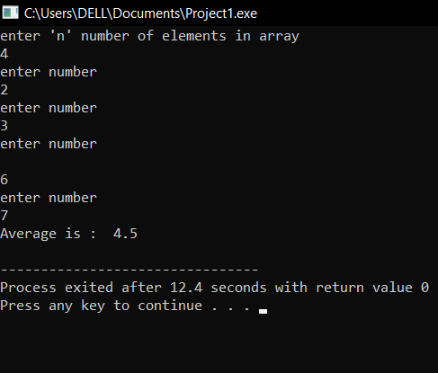

**TASK 2:**

#include <iostream>

using namespace std;

void bubbleSort(int arr[], int size) {

for (int i = 0; i < size - 1; ++i) {

for (int j = 0; j < size - i - 1; ++j) {

// Swap if the element found is greater than the next element

if (arr[j] > arr[j + 1]) {

swap(arr[j], arr[j + 1]);

}

}

}

}

int main() {

const int size = 5;

int arr[size];

// Input array elements

cout << "Enter " << size << " integers for the array" <<endl;

for (int i = 0; i < size; ++i) {

cin >> arr[i];

}

// Perform Bubble Sort

bubbleSort(arr, size);

// Display the sorted array

cout << "Sorted array using Bubble Sort"<<endl;

for (int i = 0; i < size; ++i) {

cout << arr[i] << " "<<endl;

}

cout << endl;

return 0;

}

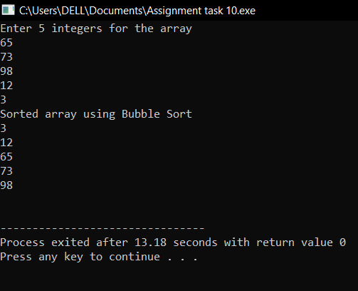

**TASK 3:**

#include <iostream>

using namespace std;

void selectionSort(int arr[], int size) {

for (int i = 0; i < size - 1; ++i) {

int min = i;

for (int j = i + 1; j < size; ++j) {

if (arr[j] < arr[min]) {

min = j;

}

}

swap(arr[i], arr[min]);

}

}

int main() {

const int size = 5;

int arr[size];

cout << "Enter " << size << " integers for the array" << endl;

for (int i = 0; i < size; ++i) {

cin >> arr[i];

}

selectionSort(arr, size);

cout << "Sorted array using Selection Sort";

for (int i = 0; i < size; ++i) {

cout << arr[i] << " ";

}

cout << endl;

}

